 | Bansilal Ramnath Agarwal Charitable Trust’s Vishwakarma Institute of Information Technology  Department of  Artificial Intelligence and Data Science
Student Name: Sathe Onkar Abasaheb
Class: TY | Division: B |  | Roll No: 372078
Semester: V |  | Academic Year: 2025-2026
Subject Name & Code: Cloud and DevOps
Assignment No: 06
Title of Assignment:Kubernetes Deployment – Set up a Kubernetes cluster and deploy a sample application.

Date of Performance: / /2025 |  | Date of Submission: / /2025

Title : Deployment of a Sample Web Application on Kubernete.

2. Objective
- Demonstrate end-to-end deployment of a sample containerized web application to a Kubernetes cluster.
- Build a Docker image, push to a container registry, create Kubernetes objects (Namespace, Deployment, Service, ConfigMap, Secret, Ingress), and validate application availability.
- Explain the deployment process, configurations, and troubleshooting steps.

Tools & Technologies
- Docker (for building images)
- Kubernetes cluster (Minikube / kind / microk8s / managed cluster like GKE/EKS/AKS)
- kubectl (Kubernetes CLI)
- A container registry (Docker Hub / GitHub Container Registry / private)
- Optional: Helm (not required)
- Basic bash / shell

Prerequisites
- Docker installed and logged into a registry.
- Kubernetes cluster available and kubectl configured (e.g., minikube start).
- Basic familiarity with YAML and command list

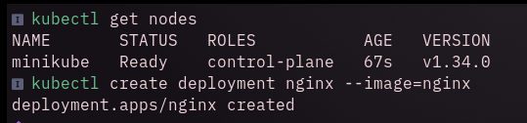
The terminal displays two Kubernetes commands and their outputs:
img 1.1
This command lists all nodes in the cluster.
- The output shows a single node named minikube, which is in the Ready state.
- Its role is control-plane, meaning it manages cluster operations.
- The cluster has been running for 67 seconds, with Kubernetes version v1.34.0.
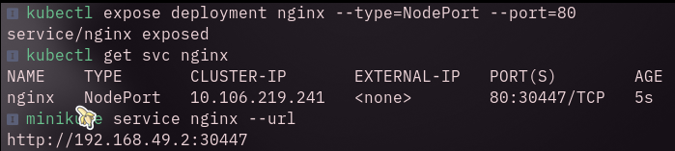
img: 1.2

The command kubectl expose deployment nginx --type=NodePort --port=80 creates a Service of type NodePort to make the Nginx application accessible outside the cluster.

kubectl get svc nginx lists the created service, showing:
- TYPE: NodePort
- CLUSTER-IP: 10.106.219.241 (internal cluster IP)
- PORT(S): 80:30447/TCP, meaning port 80 inside the cluster maps to external port 30447.
- Finally, minikube service nginx --url outputs the external access URL: http://192.168.49.2:30447

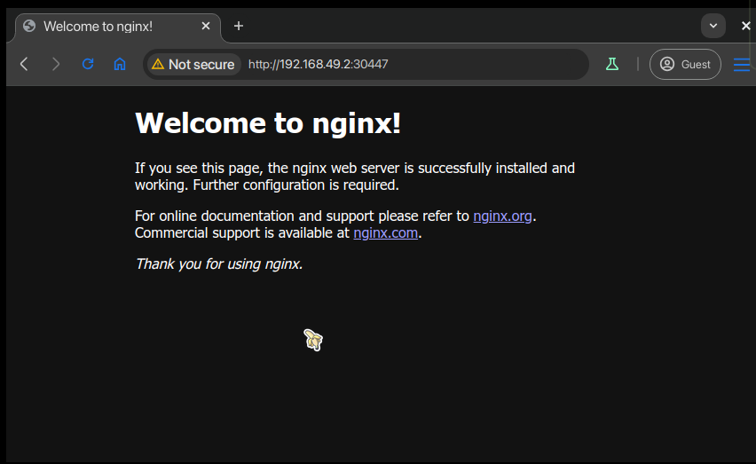
img 1.3: Ngix Server web page

Conclusion
This assignment demonstrates how a simple web application can be containerized and deployed on Kubernetes with basic production-ready considerations (readiness/liveness probes, resource limits, ConfigMap/Secrets, and scalability). Kubernetes decouples deployment from infrastructure, making scaling, updating, and configuration management straightforward. The practical exercises (build, push, apply manifests, validate) give hands-on familiarity with the typical CI/CD pipeline steps used in real projects.

